**AIM:** Write a program to calculate the weights for the following patterns using hetero associative neural net for mapping four input vectors to two output vectors.

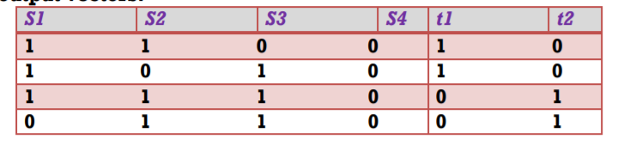

**SOURCE CODE:**

%Hetero associative NN for mapping input vectors to output vectors

x= [1 1 0 0; 1 0 1 0; 1 1 1 0; 0 1 1 0];

t= [1 0; 1 0; 0 1; 0 1];

w=zeros (4, 2);

for i=1:4

w=w+x (i, 1:4)'*t(i,1:2);

end

disp('Weight matrix');

disp(w);

**OUTPUT:**

Weight matrix

2 1

1 2

1 2